INVENTORY MANAGEMENT OPTIMIZATION PLAN
Selling more, holding less, and staying calm when the supply chain doesn’t

A strategic plan covering demand forecasting, stock-level management and risk mitigation, tested in a simulated supply chain.
Scenario company: Harbor & Pine Home Supply (hypothetical)
Scope: 240 SKUs, one supplier tier, one central distribution centre, four regional warehouses
Method: two-year weekly simulation, 8 random replications per scenario

What’s inside
1 Executive summary
2 The scenario: Harbor & Pine Home Supply
3 What the literature says
4 How we tested ideas: the simulation
5 The optimization plan, step by step
6 What the simulation showed
7 Sensitivity: demand and supply fluctuations
8 Managing risk, seasonality and disruption
9 Implementation roadmap and feasibility
10 Limitations and next steps
11 Conclusion
References
A Appendix: formulas and glossary

1. Executive summary
Harbor & Pine sells home and kitchen products through retail and e-commerce channels. Like many distributors, it manages stock with a rule that is easy to explain and easy to run: look at the last eight weeks of sales, reorder once a month, and keep three weeks of cover on top of the lead time for every product. It is a reasonable rule. It is also blind to three things that decide whether a distributor makes money: demand has a season, suppliers are sometimes late, and a few products matter far more than the rest.
We built a simulated version of the company, with 240 products, a central warehouse and four regional ones, and ran it for two years under different rules. We compared the current approach with two alternatives: a pure just-in-time approach, and an optimized policy that combines ABC segmentation, a seasonal forecast, safety stock that reflects both demand and supplier variability, and review cycles that differ by product class. Then we pushed all three through demand surges, slow suppliers and an eight-week supplier outage.
Table 1. Headline results (average of 8 simulated years)
Measure | Legacy rule | Just-in-time only | Optimized plan | Change, optimized vs legacy
Unit fill rate | 98.2% | 96.4% | 99.7% | +1.5 pts
Inventory turns | 9.1 | 22.9 | 12.1 | +33%
Average inventory value | $3.74M | $1.46M | $2.86M | −24%
Share of SKU-weeks with a stockout | 2.4% | 6.7% | 0.7% | −71%
Excess stock (beyond 6 weeks of demand) | $0.44M | $0.00M | $0.06M | −86%
Annual cost: holding + ordering + lost margin | $1.29M | $1.32M | $0.95M | −26%
Fill rate under combined stress* | 85.8% | 84.3% | 94.4% | +8.6 pts

*Combined stress: demand 20% above forecast, suppliers two weeks slower than usual, plus an eight-week supplier outage.
Three results deserve a closer look. First, the optimized plan wins on service and on stock at the same time, which is not supposed to be possible if you only turn one dial. It works because it puts inventory where it earns its keep (the A items and the seasonal peaks) and takes it away from where it doesn’t. Second, the pure just-in-time approach looks wonderful on turnover (22.9 turns) and then breaks as soon as conditions get rough. Third, the optimized plan does not make the company immune: under the combined stress its fill rate still drops to 94.4%. What it buys is a much shallower decline.
What we recommend
1. Segment first. Classify every SKU by annual value (ABC) and by demand variability (XYZ), and give each class its own service target and review rhythm.
2. Forecast with the season in it. Replace the eight-week trailing average with a level-plus-seasonal-profile model, and use a Croston-type method for slow-moving items.
3. Size buffers from real uncertainty. Calculate safety stock from measured forecast error and measured supplier lead-time variability, and refresh both every week.
4. Place stock by stage. Hold pooled buffers in the central warehouse, thin ones in regions, and keep JIT for items where suppliers are close and reliable.
5. Build the early-warning loop. Two triggers (demand beyond 2σ for two weeks, lead time up by more than a week) start a three-level response playbook.

2. The scenario: Harbor & Pine Home Supply

2.1 The business
Harbor & Pine is a mid-sized distributor of kitchen appliances, cookware, storage and small home goods. Products come from suppliers in three regions, land in one central distribution centre (DC), and are then pushed out weekly to four regional warehouses that serve retail partners and the company’s own web shop. We model 240 active SKUs, a representative slice of the core range. Together they represent about $34.5 million of annual sales at cost.
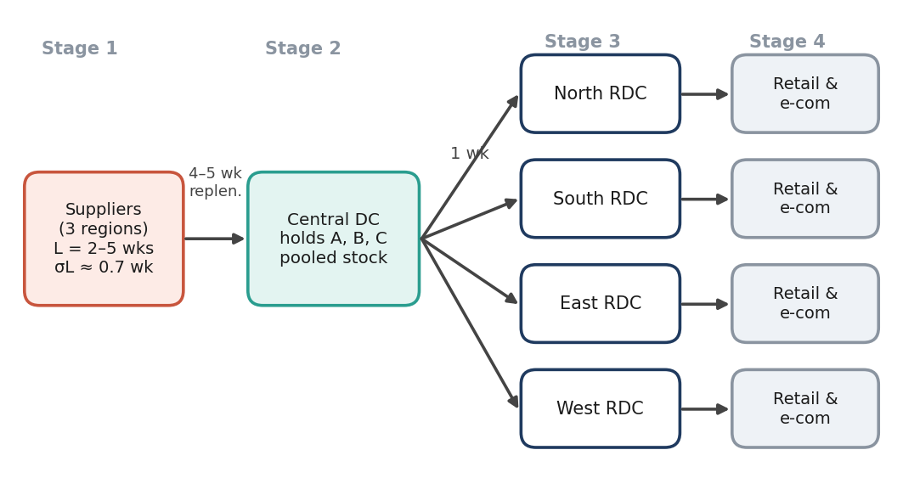
. The four stages of the simulated network. Lead times are approximate; supplier lead times vary by product.

2.2 What is going wrong today
Four problems are typical of distributors in this position, and we built all four into the legacy policy so that the comparison is fair to real life. You may recognize them.
- One rule for everything. Every SKU gets the same three weeks of safety stock and the same monthly review, whether it is a best-seller worth $400,000 a year or a niche item worth $2,000.
- A forecast that looks backwards. The eight-week trailing average always lags. It under-orders when demand is climbing into the holiday peak and over-orders when it is falling away.
- Lead times treated as fixed. The system uses the supplier’s quoted lead time. In practice about a third of orders arrive a week or more late.
- Stockouts and excess stock at the same time. Fast sellers run out in the peak while slow sellers sit on shelves for months. The planners know it; the rule gives them no way to fix it.

2.3 How we modelled it
The simulation runs week by week for 104 weeks. The first year lets every policy settle in; we measure results in the second year. All three policies see exactly the same demand and the same supplier delays in each run, so differences in results come from the policy and not from luck. Table 2 lists the assumptions.
Table 2. Simulation assumptions
Element | Assumption
Portfolio | 240 SKUs; annual sales at cost about $34.5M. ABC split by value: 49 A items (80% of value), 78 B (15%), 113 C (5%).
Demand | Weekly mean per SKU is log-normally distributed (median about 30 units). Weekly variability averages about 41% of the mean. Demand follows a seasonal pattern that runs from roughly 0.68 to 1.26 times the average week, with a sharper holiday peak around week 46.
Supply | Quoted lead times of 2–5 weeks (mean 3.3). Each order has an added delay of 0, 1, 2 or 3 weeks with probabilities 68%, 20%, 9% and 3%. Unmet demand is lost, not back-ordered.
Costs | Holding cost 25% of unit cost per year; $35 per order line; a stockout loses a margin equal to 45% of unit cost.
Run design | 104 weeks, year 2 measured; 8 random replications per scenario (5 for the sensitivity grid).
Stress scenarios | Disruption: orders placed in weeks 71–78 arrive three weeks later than they otherwise would. Demand surge: demand 20% above forecast from week 61. Combined: both, plus two extra weeks on every lead time.

3. What the literature says
Inventory theory is old, and most of what a practitioner needs was worked out long ago. What changed in the last twenty years is the recognition that the clean models need to live alongside messy supply chains. We organize the review around the questions the plan has to answer.

3.1 Classical foundations: how much, and when?
Harris (1913) gave us the economic order quantity (EOQ): order the amount that balances ordering cost against holding cost. The square-root rule is still the starting point for lot sizing, even though its assumptions (steady demand, fixed lead time) rarely hold. For uncertain demand, the newsvendor logic and its descendants say that the right stock level is a quantile of the demand distribution, set by the relative costs of running out and of having too much. Silver, Pyke and Thomas (2017) turn these ideas into the practical policies planners use: continuous review (s, Q), periodic review (R, S) and the combined (s, S) forms. The plan in this document uses a periodic-review, order-up-to policy, because it fits weekly planning cycles and consolidated supplier orders.

3.2 Segmentation: ABC and XYZ
Dickie (1951) described the idea General Electric had used: rank items by annual usage value and manage the few that dominate differently from the many that don’t. ABC analysis is not sophisticated, which is exactly why it endures. Its common extension, XYZ analysis, adds a second axis for demand variability (coefficient of variation). Together they let a planner say something sensible like “this is an A item with erratic demand, so protect it with buffer stock and review it weekly”, instead of applying one rule to everything. The weakness of ABC is that value is not the only thing that matters: criticality, shelf life and substitution possibilities can justify moving an item up a class.

3.3 Safety stock and service levels
Safety stock is the buffer against being wrong. When demand and lead time are both uncertain and independent, the textbook expression (Silver et al., 2017; Chopra & Meindl, 2016) is:
where z is the normal quantile for the target service level, L the lead time (plus the review period for periodic systems), the standard deviation of demand per period, d̅ the mean demand per period and the standard deviation of lead time. The important lesson is in the second term: supplier unreliability gets multiplied by demand volume, so a slightly erratic supplier on a fast-moving product is expensive. The formula also assumes a stable distribution and independence between demand and lead time, and both assumptions need monitoring in practice.

3.4 Forecasting: seasonality and slow movers
Forecasting errors drive safety stock, so better forecasts shrink buffers directly. Hyndman and Athanasopoulos (2021) give a clear account of the exponential-smoothing family, which handles level, trend and seasonality with few parameters and is robust at the SKU level. For intermittent demand, where most weeks are zero, Croston (1972) proposed forecasting the demand size and the interval between demands separately; Syntetos and Boylan (2005) corrected a bias in his approach. The M5 forecasting competition (Makridakis, Spiliotis & Assimakopoulos, 2022) found that machine-learning methods trained across many related series beat the statistical benchmarks on retail data. That is encouraging for the longer term, though simple methods remain competitive on small portfolios and are far easier to explain to planners. We use the simple route and keep machine learning as a later upgrade.

3.5 Just-in-time and lean
Just-in-time (JIT), developed at Toyota and described by Ohno (1988), treats inventory as a form of waste that hides problems. Small, frequent replenishments and tight coordination with suppliers cut holding costs and expose quality and process issues. The conditions matter, though: JIT thrives where demand is levelled, lead times are short and suppliers are reliable and nearby. Where those conditions fail, removing buffers removes the shock absorber. Christopher and Peck (2004) and Sheffi (2005) argued that lean efficiency and resilience pull in different directions, and the disruptions of the early 2020s led many firms to re-examine thin-inventory models (Ivanov & Dolgui, 2020). Our simulation reproduces this tension in a small way: the JIT-only policy has by far the best turnover and the worst behaviour under stress.

3.6 multi-stage networks, pooling and the bullwhip
Clark and Scarf (1960) showed that in a serial multi-stage system the best stocking decisions at each stage depend on the stages downstream and upstream, which is why optimizing each warehouse in isolation is a mistake. EpiPen (1979) showed that holding stock centrally rather than at each location reduces the buffer needed for demand variability, roughly in proportion to the square root of the number of locations pooled. Graves and Willems (2000) developed the guaranteed-service approach for deciding where in a network to hold safety stock. Lee, Padmanabhan and Whang (1997) described the bullwhip effect: small swings in consumer demand become large swings in orders as they move upstream, driven by forecast updating, order batching, price fluctuations and shortage gaming. The practical consequences are to forecast from the closest possible demand signal and to keep review cycles and batch sizes from amplifying noise.

3.7 Resilience
Shefi (2005) and Christopher and Peck (2004) frame resilience as a set of capabilities: redundancy (buffers, spare capacity), flexibility (multiple sources, rerouting), and visibility with fast decision-making. Lee (2002) added a useful segmentation principle: match the supply chain strategy to the product, so that predictable products can run lean and unpredictable ones need responsiveness and buffers. This sits well with ABC-XYZ thinking and underpins the way our plan treats JIT as a tool for particular items instead of a company-wide philosophy.
Table 3. Synthesis: what each technique solves, where it falls short, and how we use it
ABC / XYZ | Focuses effort on the items that matter | Value is not the only criterion | Drives service targets and review cycles
Safety stock formula | Converts uncertainty into a buffer | Needs good estimates of σd and σL | Re-estimated weekly from observed errors and receipts
Seasonal smoothing, Croston | Removes lag in forecasts; handles lumpy items | Needs a stable season; Croston can lag after regime shifts | Core forecasting engine
JIT / lean | Cuts holding cost and exposes problems | Fragile to supplier or demand shocks | Applied selectively to C items with short, reliable lead times
Risk pooling, multi-echelon | Reduces total buffer for demand variability | Does not pool lead-time risk; needs coordination | Central DC holds pooled buffers; regions hold thin ones
Resilience tactics | Prepares for disruptions | Costs money before it pays | Three-level playbook and targeted buffers on A items

4. How we tested ideas: the simulation
Figure 2 shows the loop we propose, from data to orders and back again. The same loop is what we coded into the simulation, so the results in Sections 6 and 7 test the plan as written.
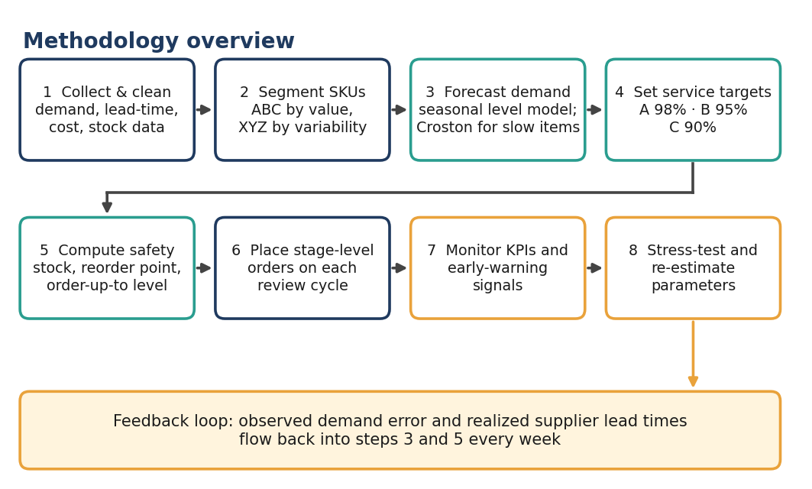
End-to-end methodology. The feedback loop at the bottom is what keeps the plan honest when the world changes.
We compared three policies. They differ in how they forecast, how they size buffers and how often they review.
Table 4. The three policies compared
 | Legacy rule | Just-in-time only | Optimized plan
Forecast | Average of the last 8 weeks | Seasonal level model (same as optimized) | Seasonal level model, updated weekly (smoothing 0.15)
Safety stock | Three weeks of average demand for every SKU | None | z × √(…) from measured forecast error and lead-time variance
Service target | Not defined | Not defined | A 98%, B 95%, C 90% (cycle service level)
Review cycle | Every 4 weeks, all SKUs | Weekly, all SKUs | A weekly, B every 2 weeks, C every 3 weeks
Lead time used | Quoted lead time | Learned from receipts | Learned from receipts (weight 0.25 on the latest)
Order rule | Order up to average × (L + 4 + 3) | Order up to forecast over L + 1 | Order up to forecast over (L + R) plus safety stock

Two modelling choices are worth flagging. The “just-in-time” policy here is the optimized forecasting engine with the buffers removed, which is generous to JIT, since real JIT systems also rely on supplier collaboration that a simulation cannot capture. And the legacy rule’s three weeks of safety stock is a typical value, not one we tuned to make the comparison look good; we also tested it from half a week to five weeks (Section 6).

5. The optimization plan, step by step
Each step below says what to do, what it needs and why it works. They are meant to be done in order, but the loop in Figure 2 means steps 3 to 5 repeat every week once the system is live.

Step 1. Prepare the data
Before any modelling, assemble 24 months of weekly demand by SKU and location. Use demand rather than sales: when a SKU stocked out, the sales figure understates what customers wanted, so lost-sales weeks should be flagged and corrected. Pull every purchase-order receipt to compute realized lead times (order date to receipt date) by supplier and SKU. Add unit cost, supplier minimum order quantities and pack sizes. This is the least glamorous step and the one most likely to be underestimated; it is common for a third of the project time to disappear here.

Step 2. Segment the portfolio
Rank SKUs by annual sales at cost and cut at 80% and 95% of cumulative value. In our scenario this yields 49 A items, 78 B items and 113 C items (Figure 3). Then add the XYZ axis using the coefficient of variation of weekly demand (for instance X below 0.3, Y 0.3 to 0.6, Z above 0.6). Finally, apply a short override list for items whose criticality is not captured by value: anchor products for key customers, items with long approval cycles, and items with very short shelf life.
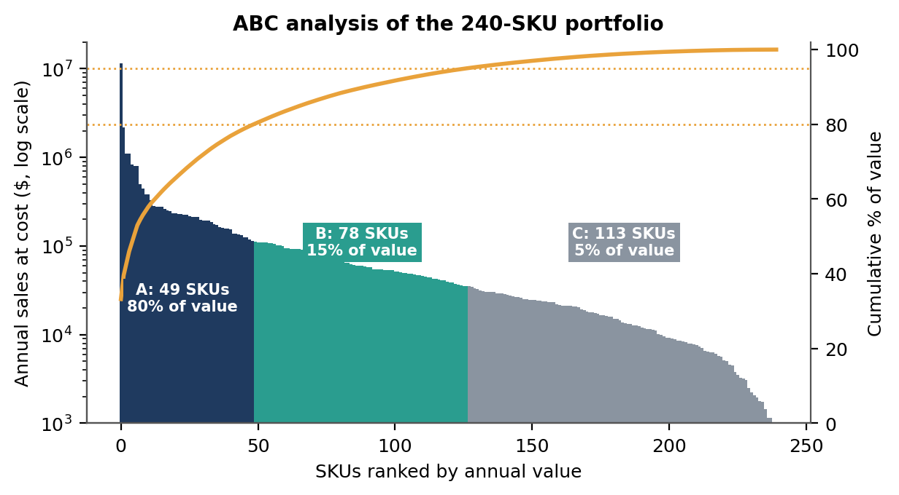
. ABC analysis. Just 49 of 240 SKUs generate 80% of the value, so service targets and planner attention should be concentrated there.
Table 5. Policy by segment
Class | Share of SKUs / value | Service target | Review cycle | Planner attention
A | 20% / 80% | 98% | Weekly | Item-level, weekly review of exceptions
B | 33% / 15% | 95% | Every 2 weeks | Group-level, review by exception
C | 47% / 5% | 90% | Every 3 weeks | Automated; candidates for JIT or vendor-managed stock

Step 3. Build a forecast that knows about the season
For regular items, we maintain a de-seasonalized demand level for each SKU and multiply it by a seasonal index. The index is estimated once a year from the pooled demand of the whole portfolio, which is much steadier than SKU-level seasonality, and lightly smoothed over three weeks. The level updates each week:
The forecast over the next H weeks is the level multiplied by the sum of the seasonal indices for those weeks. A trailing average ignores the season and so lags it; the seasonal model leans into it (Figure 4). At the SKU level the seasonal model cut forecast error (weighted absolute percentage error) from 33.9% to 31.5%. That sounds modest, and it is, because much of the week-to-week noise cannot be forecast by any method. The value is not in the headline accuracy but in removing the predictable bias around the peaks, where stockouts concentrate.
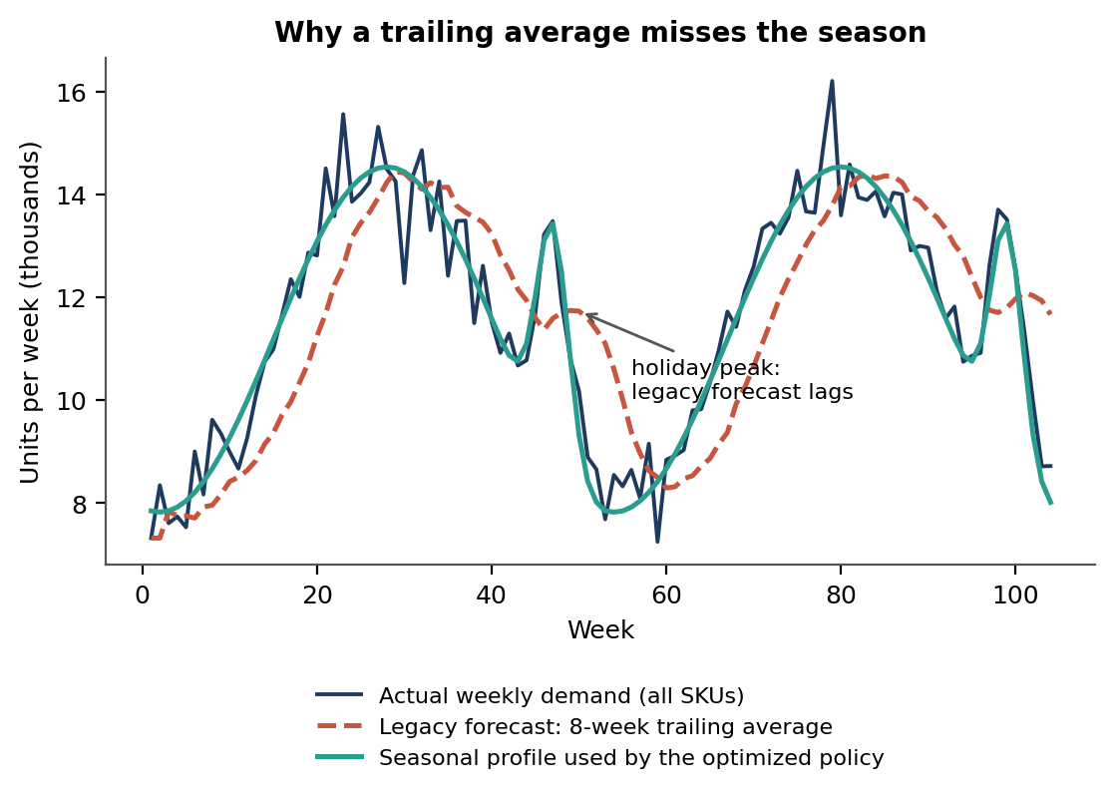
Total weekly demand across all SKUs. The trailing-average forecast chases the peak after it has arrived; the seasonal profile anticipates it.
For slow movers with many zero weeks (typically C items), use Croston’s method with the Syntetos-Boylan correction, and set their buffers using a service-level target on lead-time demand instead of the normal approximation. Where a new product has no history, borrow the seasonal profile and starting level from a similar product and let actual sales take over after about eight weeks.

Step 4. Set service targets and compute safety stock
Targets reflect the cost of being out of stock against the cost of holding. The cost of being wrong is not the same for every item, which is the reason behind the 98/95/90 split. For each SKU and each week we compute:
where L̅ is the current estimate of mean lead time, R the review period, σd the weekly forecast-error standard deviation (an exponentially weighted estimate, so it adapts), F the forecast over H weeks and σL the lead-time standard deviation estimated from recent receipts. Figure 5 shows why the lead-time term matters. For a product selling 150 units a week with a demand standard deviation of 40, moving the supplier’s lead-time standard deviation from zero to one and a half weeks roughly triples the safety stock needed for a 98% target.
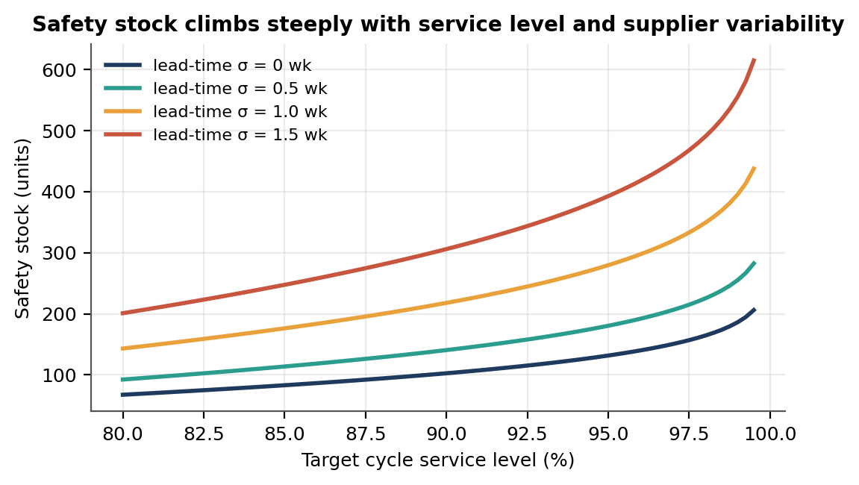
Safety stock needed for a product with mean demand of 150 units a week, weekly demand σ of 40 and a 4-week lead time.

Step 5. Set reorder points and order-up-to levels
With a forecast and a buffer, the stock levels follow directly. In a periodic-review system we use an order-up-to level S and the inventory position IP, which is on-hand stock plus orders already placed, less anything committed:
S = F(L̅ + R) + SS Order quantity Q = S − IP (when IP < S at a review)
Reorder point (continuous-review equivalent): ROP = d̅ × L̅ + SS
Orders are then rounded to pack size and supplier minimums. For C items where the EOQ suggests a larger batch than the review cycle gives, we lengthen the cycle in preference to inflating the order, so cash is not tied up in a stock of slow-moving items.

Step 6. Place stock sensibly across the stages
The network in Figure 1 has four stages, and where we hold buffers matters as much as how big they are. The principle is: hold the supplier-risk buffer where demand is pooled (the central DC), and hold only a thin buffer close to the customer, sized for the short last leg. Pooling halves the demand-variability part of the buffer when four regions are combined, because the standard deviation of the total is 2× that of one region, not 4×. It does not pool lead-time risk, which hits all regions together. Table 6 gives a worked example for one A item.
Table 6. Worked example: a 5-litre air fryer (A item, 98% target, review weekly)
Stage | Mean demand / wk | Demand σ / wk | Lead time (σ) | Safety stock | Order-up-to level S
Central DC (pooled) | 480 | 80 | 4 wks (1.0) | 1,052 | 3,452
Regional warehouse (each of 4) | 120 | 40 | 1 wk (0.3) | 138 | 378
Retail / e-commerce | n/a | n/a | n/a | Display minimum only | n/a

Two points about that table. The DC buffer protects against supplier lateness for all four regions at once, so one pool of 1,052 units is doing a job that four separate pools could not do for the same total. And the stage buffers are not simply additive: if the DC is reliable at 98% and each region also targets 98%, the customer-facing service is a combination of both, so in a real implementation we would set the DC target slightly lower (for example 96%) and tune with the guaranteed-service model of Graves and Willems (2000).
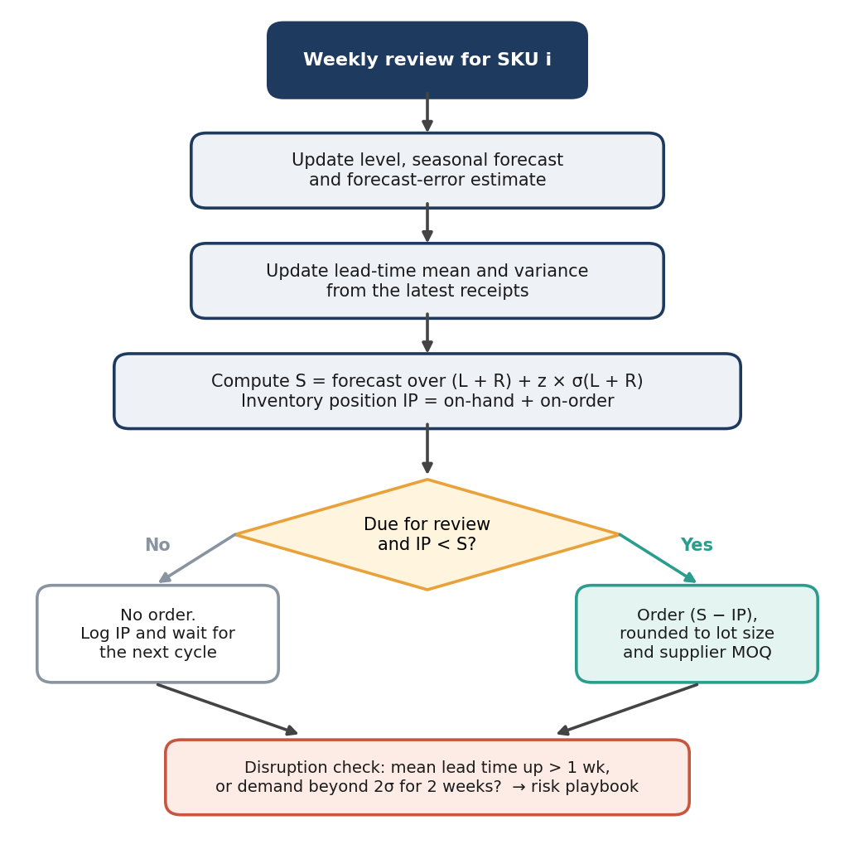
. The weekly review logic for one SKU, with a disruption check at the end of every cycle.

Step 7. Decide where just-in-time belongs
We do not reject JIT; we ration it. A C item is a good JIT candidate when its supplier is within a short lead time (two weeks or less), when its lead-time variability is low (σL below 0.5 weeks), and when a stockout is cheap, meaning a substitute exists or the margin is small. For these items, shift to small, frequent replenishment, and consider vendor-managed inventory so the supplier holds the buffer. A items from long, variable supply routes are the opposite case. They should keep buffers, because the simulation shows what happens without them.

Step 8. Run the weekly rhythm
- Monday: system refreshes forecasts, errors and lead-time estimates; proposed orders are generated for SKUs due for review.
- Tuesday: planners review exceptions (A items with large order changes, any SKU with a disruption flag) and release orders, consolidated by supplier.
- Weekly control tower: a 30-minute meeting looks at five KPIs: fill rate, turns, excess stock, forecast bias and supplier on-time delivery.
- Monthly S&OP: commercial, finance and supply chain agree on promotions, new products and any planned supplier changes that the statistical forecast cannot know about.
- Quarterly: re-segment SKUs, refresh seasonal indices, and review service targets against margin data.

6. What the simulation showed

6.1 Normal conditions
Under the baseline conditions (seasonal demand, ordinary supplier delays, no special shocks) the optimized plan raised the fill rate from 98.2% to 99.7%, reduced average inventory from $3.74M to $2.86M and lifted turnover from 9.1 to 12.1 (Figure 7). Excess stock, defined as inventory beyond six weeks of average demand, fell by 86%. Total annual cost, adding holding, ordering and lost margin, dropped from $1.29M to $0.95M.
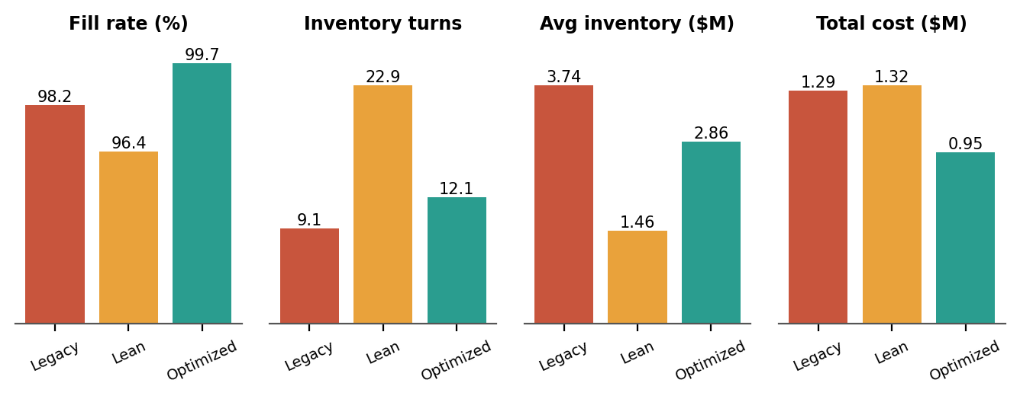
Figure 7 service.
Where do the savings come from? The cost breakdown (Figure 10) shows that holding cost falls by around $0.2M, lost margin from stockouts falls by about $0.23M, and ordering cost rises by around $0.11M because the optimized plan places about twice as many order lines. That last point is a real trade-off. If each extra order line carries real freight or handling cost, the plan’s advantage shrinks. We address this in Section 9 by consolidating orders by supplier and by lengthening the review cycle for C items.
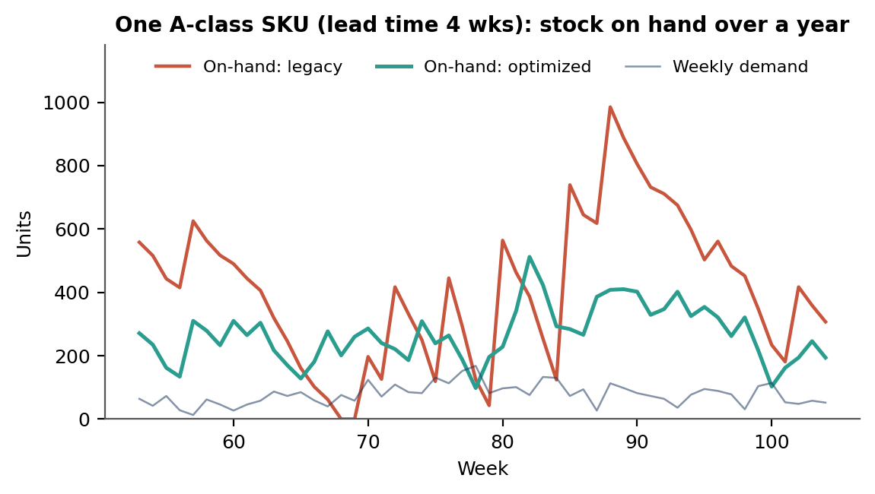
One mid-sized A item over the measurement year. The legacy rule holds stock in the quiet months and thins out right as demand climbs; the optimized policy builds ahead of the season.

6.2 The efficiency fronty
A fair objection to any comparison is that the legacy rule could simply hold more stock. It can, and Figure 9 shows what that costs. We re-ran the legacy rule with safety stock from half a week to five weeks, and the optimized policy with its service targets shifted up and down. To reach about 99% fill, the legacy rule needs roughly $4.4M of inventory. The optimized policy gets to 99.3% at roughly $2.4M, around 45% less stock. The curves do not cross: at every level of service, the optimized policy needs less inventory.
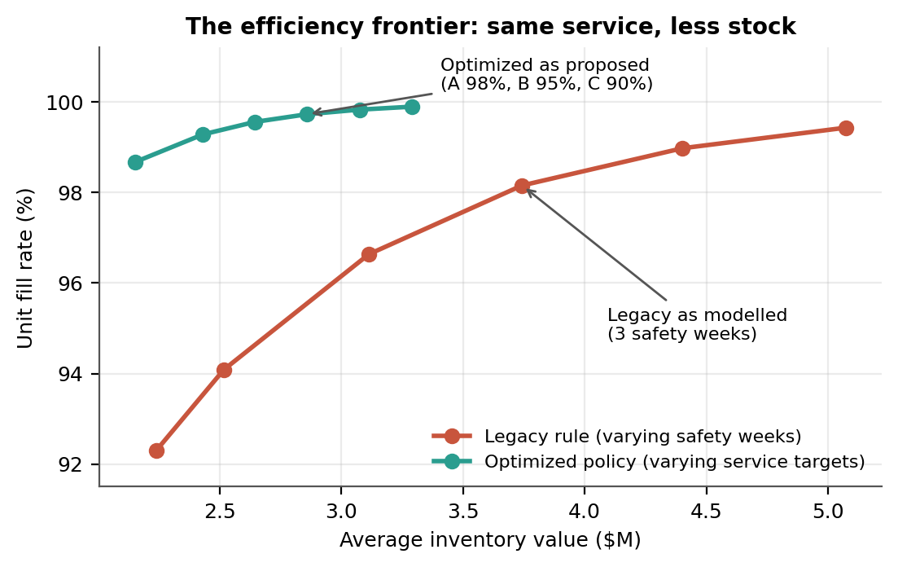
Inventory required for a given fill rate. The optimized policy sits above and to the left of the legacy rule everywhere.
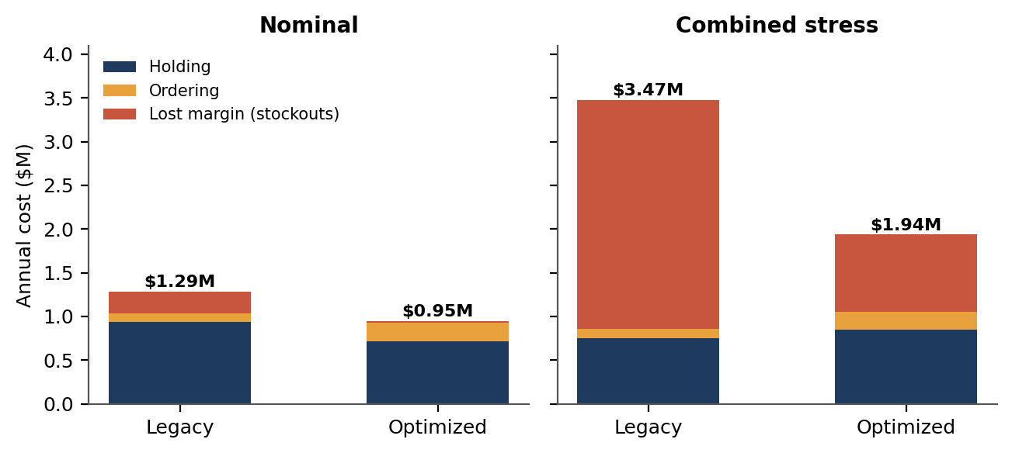
Annual cost split into holding, ordering and lost margin, in normal conditions and under combined stress.

7. Sensitivity: demand and supply fluctuation
A plan that only works when the forecast is right is not much of a plan. We tested how each policy behaves when reality departs from expectations, using a grid of forecast demand shifts (from 20% below to 30% above forecast) and supplier slow-downs (from none to three extra weeks on every lead time). Shocks begin in week 61 and none of the policies is told in advance. The optimized plan has an advantage because it learns the new lead times from receipts, but it has no foreknowledge.
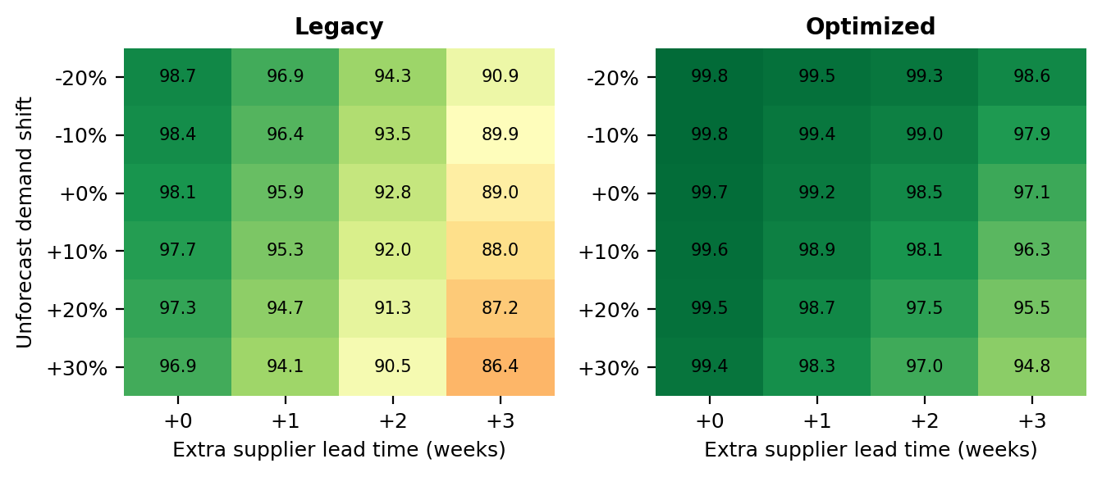
Reading across the grid, the legacy rule’s fill rate runs from 98.7% in the best corner to 86.4% in the worst, a spread of 12 points. The optimized plan runs from 99.8% to 94.8%, a spread of 5 points. The cost picture is similar. When suppliers add three weeks to every lead time with no demand change, annual cost rises from $1.30M to $2.31M under the legacy rule (+78%) and from $0.96M to $1.22M under the optimized plan (+27%). The honest reading is that the optimized plan does not hold its 98% to 99% target in the worst corner (it falls to 94.8%), but it degrades far more gently.
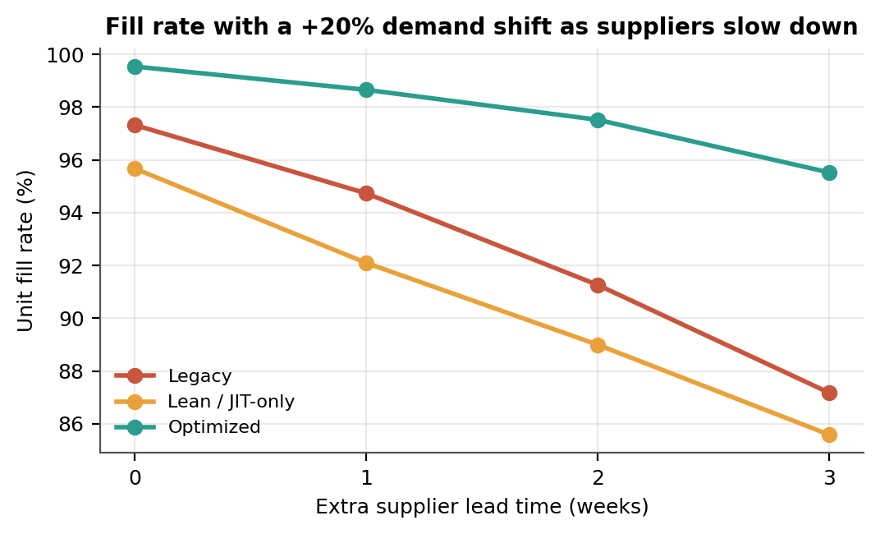
The JIT-only policy shows what happens when buffers are removed. It starts at 95.7% fill with the +20% demand shift and falls to 85.6% fill with a three-week lead-time stretch. This is not a surprise, but seeing it in numbers makes the point concrete: the cost of lean is paid in the bad weeks.

7.1 An eight-week supplier outage
We also modelled a discrete event: for eight weeks, every order placed arrives three weeks later than usual. Figure 13 tracks weekly fill rate and inventory. All three policies dip while orders are stuck in transit, and all three recover over a similar stretch once supply normalizes, at about week 85. The difference is the depth of the dip: the optimized plan’s weekly fill rate bottoms out near 84%, compared with about 67% for the legacy rule and 53% for JIT-only. One side effect is visible in the lower panel: when the delayed orders finally land, inventory bulges for a few weeks, and the monthly excess review should be ready for it. Over the full year, fill rate was 97.5% against 93.8% for the legacy rule and 91.5% for JIT-only, and annual cost was $1.33M against $1.91M and $2.06M.
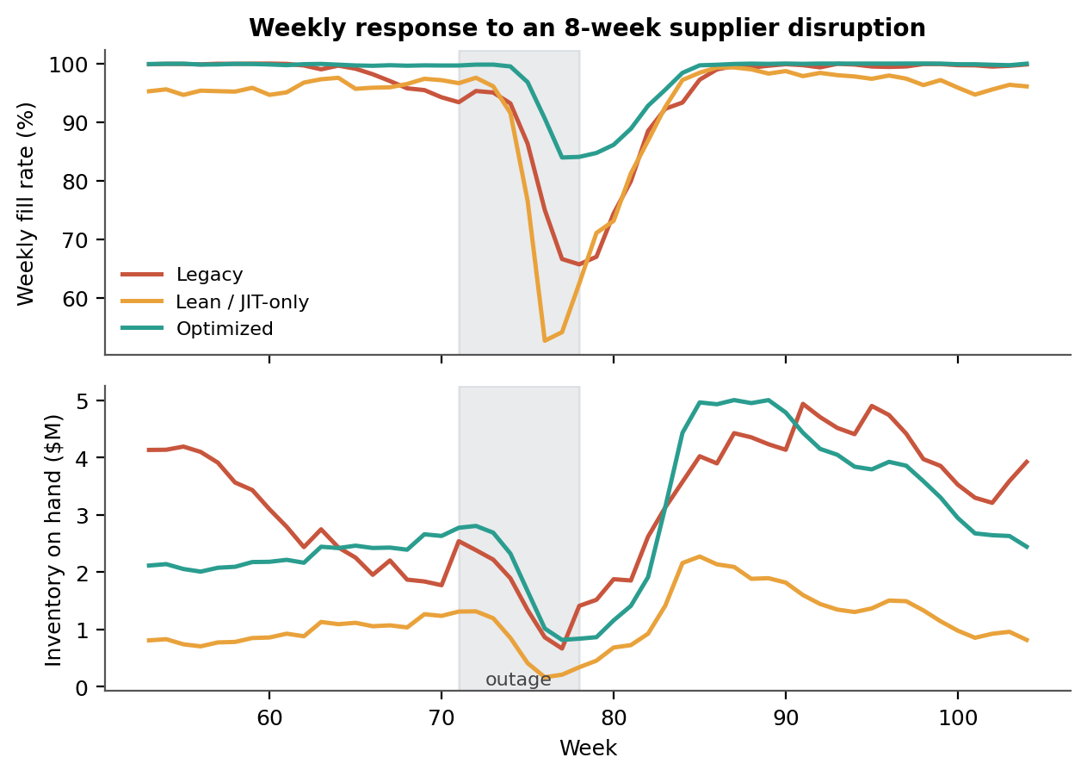
Table 7. Results by scenario (8 replications each)
Scenario | Policy | Fill rate | Turns | Avg inventory | Annual cost
Normal | Legacy | 98.2% | 9.1 | $3.74M | $1.29M
 | Optimized | 99.7% | 12.1 | $2.86M | $0.95M
Supplier disruption | Legacy | 93.8% | 9.4 | $3.47M | $1.91M
 | Optimized | 97.5% | 10.8 | $3.15M | $1.33M
Demand surge (+20%) | Legacy | 97.5% | 9.4 | $4.24M | $1.59M
 | Optimized | 99.6% | 12.8 | $3.19M | $1.05M
Combined stress | Legacy | 85.8% | 11.6 | $3.02M | $3.47M
 | Optimized | 94.4% | 11.5 | $3.39M | $1.94M

One detail in that table is worth a second look. In the combined-stress scenario, the legacy rule’s turnover looks better (11.6) than in normal conditions, and that is a warning sign, not an improvement. Turnover rises because the legacy rule is out of stock, so there is less inventory to turn and less to sell. A turnover figure on its own can hide a service failure, which is why we always report it next to fill rate.

8. Managing risk, seasonality and disruption
The statistical buffers in Section 5 handle ordinary variation. Seasons and genuine disruptions need deliberate management on top, and that is the job of the playbooks below.

8.1 Seasonal playbook
Table 8. A seasonal calendar for planners
When | What happens | What we do
10–12 weeks before peak | Seasonal index rises; suppliers start to fill capacity | Confirm peak volumes with top suppliers; book capacity; allow pre-build for A items with lead times of 4 weeks or more
6–8 weeks before peak | Order-up-to levels climb automatically as the forecast horizon enters the peak | Review the top 20 A items by hand; check that supplier lead-time quotes include peak congestion
Peak weeks | Highest stockout risk; forecast error is largest | Move to twice-weekly review for A items; rebalance across regions each week; pause promotions on items under 2 weeks of cover
2–4 weeks after peak | Demand falls faster than orders can be cancelled | Cancel or defer open orders for items above target; flag excess; plan clearance for items above 8 weeks of cover
Off-season | Low risk, an opportunity to fix things | Refresh seasonal indices, re-segment SKUs, renegotiate supplier terms

8.2 Disruption playbook
Disruptions are different from noise: they are rare, large and often visible only in hindsight. The aim is to spot them early and respond in proportion. Two triggers feed the control tower. The demand trigger fires when forecast error exceeds twice its usual standard deviation for two weeks running. The supply trigger fires when the rolling average lead time for a supplier rises more than a week above its quoted value, or when the supplier’s on-time rate falls below 90%. Once both fires, the response escalates in three levels (Figure 14).
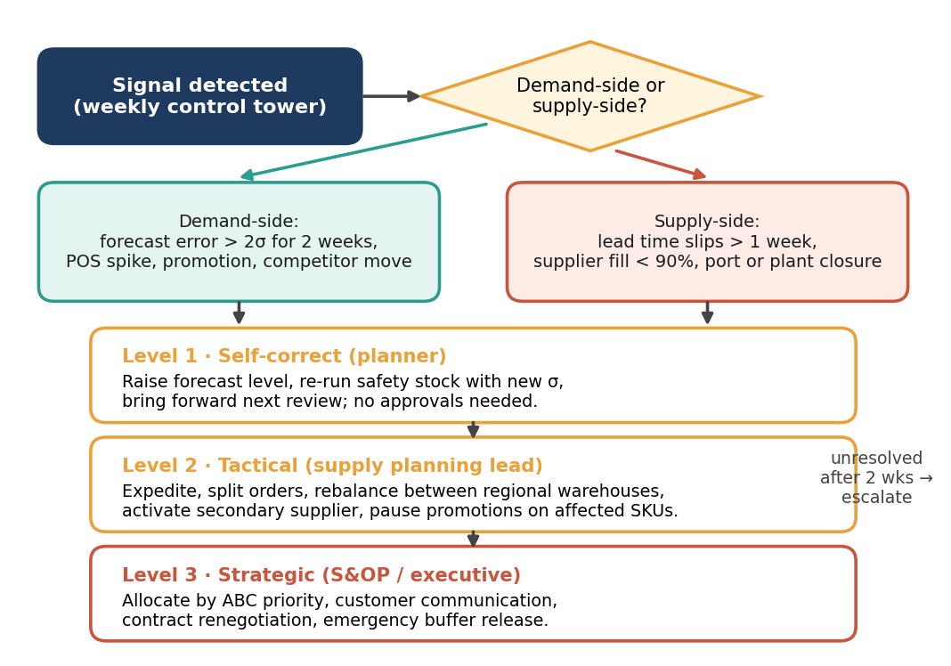
.

8.3 Risk register
Table 9. Principal risks and responses
Risk | Likelihood / impact | Early signal | Response | Owner
Supplier delay or outage | Medium / High | Receipts later than quoted; supplier fill < 90% | Lead-time estimate updates automatically; expedite; split orders; qualify a second source for top A items | Supply planning lead
Demand surge | Medium / Medium | Forecast error > 2σ for 2 weeks; sell-through spike | Raise level; rebalance regions; ration C items before A items | Demand planner
Demand collapse | Low / Medium | Sell-through well below forecast | Cancel open orders; stop promotions; markdown plan | Category manager
Forecast bias after a launch or promotion | High / Low | Persistent one-directional error | Bias tracking by SKU; planner override with expiry date | Demand planner
Data quality problems | Medium / High | Negative stock, impossible lead times | Daily exception reports; owner for master data | Inventory control
Over-reliance on the model | Medium / Medium | Planners stop questioning outputs | Exception review for A items; quarterly back-testing | Head of supply chain
Cash tied up in excess stock | Medium / Medium | Cover > 8 weeks on non-seasonal items | Monthly excess review; supplier return agreements | Finance partner

8.4 Supplier and network strategies
- Dual-source selectively. Qualify a second supplier for the 10–15 A items where a single-source stockout would hurt most, even if the second source costs a few percent more.
- Share demand data. Giving key suppliers a 12-week rolling forecast reduces their uncertainty and often their lead-time variability. This also helps contain the bullwhip effect.
- Hold an emergency buffer. Set aside a small strategic reserve for the top A items, released only at Level 3, so that planners do not quietly raise everyday safety stock “just in case.”
- Use time flexibility where you can. Air freight, partial shipments and alternative ports are expensive, but when used on 5% of volume during a crisis, they cost less than the lost sales.

9. Implementation roadmap and feasibility
The plan needs no new warehouse and no new category of technology. It does need disciplined data, a planning tool that can run weekly calculations (a spreadsheet can start the job, an ERP or planning module can finish it) and a team willing to trust exceptions over habit. We recommend three phases.
Table 10. Roadmap
Phase | Main activities | Deliverables | Success measure
Days 0–30: Foundation | Clean 24 months of demand and receipts; compute ABC/XYZ; measure current fill rate, turns, forecast bias and supplier on-time rates; agree service targets with commercial team | Segmented SKU master; baseline KPI dashboard | Baseline agreed; data quality issues logged and owned
Days 31–90: Pilot | Run the optimized policy in parallel on the 49 A items and a sample of B items in one region; track planner overrides; compare proposed orders with actual | Shadow-mode report; calibrated parameters | Pilot fill rate at or above target; overrides below 15% of orders
Days 91–180: Rollout | Switch live ordering for A and B items; start C-item review cycles; set up control tower; implement risk playbooks; supplier data-sharing for top suppliers | Live weekly cycle; playbooks signed off | Turns up 20%+ and stockouts down by half, versus baseline
Beyond day 180: Improve | Add Croston for slow movers; multi-echelon optimization; test ML forecasting; test vendor-managed stock for C items | Quarterly review pack | Continued gains without service loss

9.1 Resources and cost
A small team can deliver this: one supply-chain analyst for the data and the model, one demand planner as the process owner, an ERP or IT contact for data extracts and order integration, and a finance partner to validate cost assumptions. Software is the cheapest part: the core calculations run in a spreadsheet or a short script. The expensive parts are people’s time and attention during the pilot. Using the simulated numbers, the plan lowers total annual cost (holding, ordering and lost margin) by roughly $0.34M, which looks comfortably larger than the effort involved; but we would not put that figure in a business case until the pilot confirms it on real data.

9.2 Practical hurdles, and how we would handle them
- Planners distrust the numbers. Shadow mode lets them compare the proposals with their own orders before anything goes live. Showing the reasoning behind each proposal (the forecast, the buffer, the lead-time estimate) matters more than the maths.
- More order lines. The plan places about twice as many orders. Consolidate by supplier and week so that the freight impact is small; if costs still rise, lengthen the review cycle for B and C items and re-run the cost comparison.
- Supplier minimum order quantities. Where an MOQ exceeds a few weeks of demand, treat it as a constraint in the order-up-to calculation and consider negotiating mixed-SKU minimums.
- Commercial teams add demand the model cannot see. Promotions and launches go through the monthly S&OP and are entered as dated overrides, so they expire and do not pollute the baseline.

9.3 KPIs and targets
Table 11. Scorecard
KPI | Baseline (simulated) | Target after 6 months | Review cadence
Unit fill rate (A / B / C) | 98.2% overall | ≥ 99% / 98% / 95% | Weekly
Inventory turns | 9.1 | ≥ 11 | Monthly
Stockout SKU-weeks | 2.4% | ≤ 1.0% | Weekly
Excess stock (> 6 weeks cover) | $0.44M | ≤ $0.15M | Monthly
Forecast bias (A items) | Not measured | Within ±5% | Weekly
Supplier on-time-in-full | About 68% on time | Track; escalate below 90% | Weekly

10. Limitations and next step
We would rather be upfront about what this study can and cannot tell you.
- It is a simulation. The company, the demand patterns and the supplier delays are invented. We tried to make them plausible, but the size of the gains in a real firm will depend on how bad its starting point is. Our legacy rule is a plausible one, and a company already doing segmentation and seasonal forecasting would see smaller gains.
- Single-stage simulation. The simulation runs at the level of the whole network with one buffer point per SKU. The stage-level worked example in Section 5 is analytical, and a full multi-echelon simulation (with its own interaction effects) is a natural next step.
- Lost sales and simple costs. We assume unmet demand is lost, with a flat margin penalty. Back-orders, customer penalties and the long-term damage of stockouts would raise the value of service.
- Independent suppliers and delays. Real disruptions are correlated across products and suppliers. Our outage scenario captures that to a degree, but a regional disaster could be worse.
- Normal-error assumption. The safety-stock formula assumes roughly normal forecast error. Lumpy items and heavy tails need extra car it e.
Sensible next steps: are like re-run the model on twelve months of real data; add multi-echelon optimization; test a machine-learning forecaster against the seasonal model; and trial vendor-managed stock with two or three suppliers.

11. Conclusion
Harbor & Pine’s problem is not too little inventory or too much. It is that inventory is in the wrong place at the wrong time, because one rule is being asked to handle products, seasons and suppliers that behave very differently. The plan in this document replaces that rule with a few connected ideas: segment by importance, forecast with the season, size buffers from measured uncertainty, put stock where pooling helps to , and keep watching for signs that the world has moved.
In our simulation this raised fill rate while cutting stock by almost a quarter, and in the stressful scenarios it protected service far better than the alternatives. Just-in-time, applied everywhere, was the most efficient policy until the first real disturbance and the least resilient after it. That is the central lesson from both the literature and the numbers: efficiency and resilience are not opposites, but you have to decide, item by item, how much of each you need.
If you take only one thing away, take this. Start with the pilot. Run the optimized policy in shadow mode for ninety days, on real data like primary , next to the current process. If it is half as good as the simulation suggests, the results will make the case for you.

References
Chopra, S., & Meindl, P. (2016). Supply chain management: Strategy, planning, and operation (6th ed.). Pearson.
Christopher, M., & Peck, H. (2004). Building the resilient supply chain. The International Journal of Logistics Management, 15(2), 1–14.
Clark, A. J., & Scarf, H. (1960). Optimal policies for a multi-echelon inventory problem. Management Science, 6(4), 475–490.
Croston, J. D. (1972). Forecasting and stock control for intermittent demands. Operational Research Quarterly, 23(3), 289–303.
Dickie, H. F. (1951). ABC inventory analysis shoots for dollars, not pennies. Factory Management and

Appendix A. Formulas and glossary
Table 12. Formulas used in the plan
Quantity | Formula
Combined safety stock | SS = z × √( H·σd² + d̅²·σL² ), with H = L + R
Order-up-to level | S = F(H) + SS, where F(H) is forecast demand over H weeks
Order quantity | Q = max(0, S − IP) at each review
Reorder point | ROP = d̅ × L + SS
Economic order quantity | EOQ = √( 2DK / h ), with D annual demand, K cost per order, h holding cost per unit per year
Inventory turnover | Annual cost of goods sold ÷ average inventory value
Unit fill rate | Units shipped from stock ÷ units demanded
Weighted absolute percentage error | Σ|actual − forecast| ÷ Σ actual

Table 13. Glossary
Term | Meaning in plain words
ABC / XYZ analysis | Sorting items by how much money they make (ABC) and how unpredictable their demand is (XYZ).
Cycle service level | The chance of getting through a replenishment cycle without running out.
Fill rate | The share of customer demand met straight from stock.
Inventory position | Stock on the shelf plus stock on order but not yet arrived.
JIT (just-in-time) | Getting goods in small amounts, right when needed, to avoid holding stock.
Lead time | Time between placing an order and receiving it.
Order-up-to level | The target inventory position that each order tops the stock back up to.
Risk pooling | Holding stock in one central place so that random ups and downs in different regions partly cancel out.
Safety stock | Extra stock held to protect against forecast errors and late deliveries.
S&OP | Sales and operations planning: the monthly meeting where commercial and supply teams agree on one plan.

